Wei-Yin Ko

FinDocAnalyzer v.0.007

USER MANUAL

HELLO THERE!

Thanks for trying out the FinDocAnalyzer—the tool for getting quick valuation with one button click! There are only three steps required for you to get the information you want.

Before we move on…:

Assuming that you are running the application locally, first you need to download Node.js [here](https://nodejs.org/en/download/). Once that is done, use the command prompt to navigate to the project folder and type **npm install** to install the needed modules and more (because I accidently imported them from another project…)! Once that is done, type in **node server.js** to kickstart the server and run FinDocAnalyzer in Java to start the program!

Step 1:

Double-click on **index.html**. You should see this upon startup:

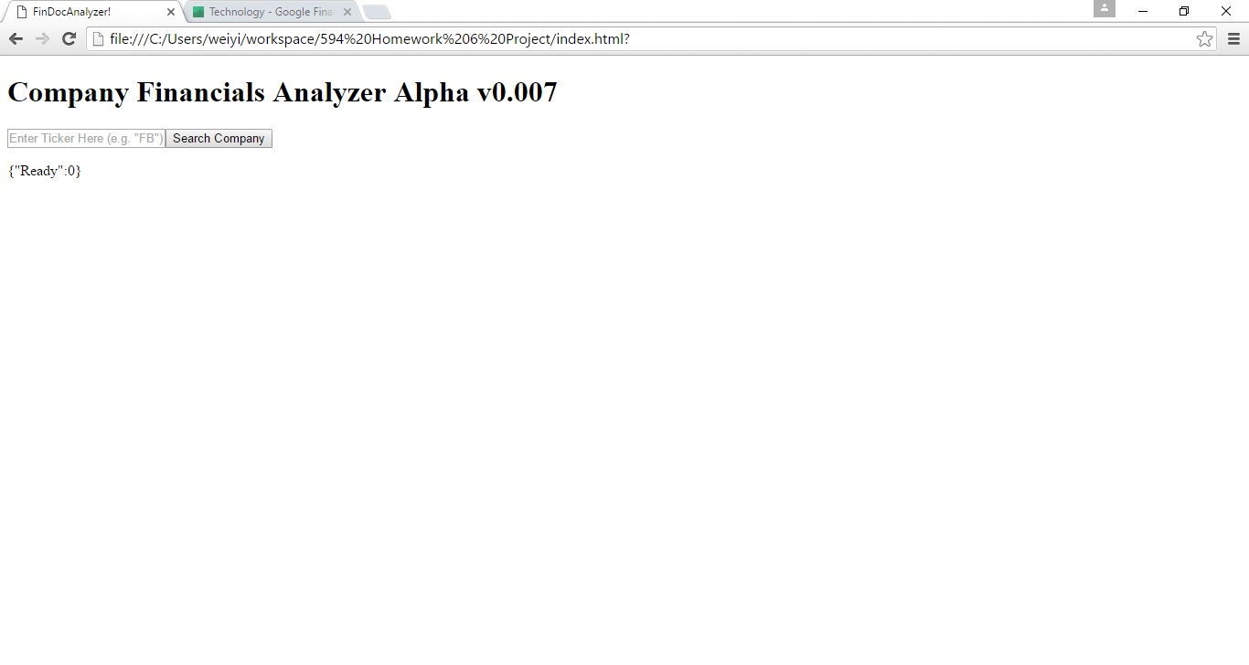

Step 2:

Type in a ticker symbol, in this case I typed in Apple’s, which is AAPL. Once that is done press the button!

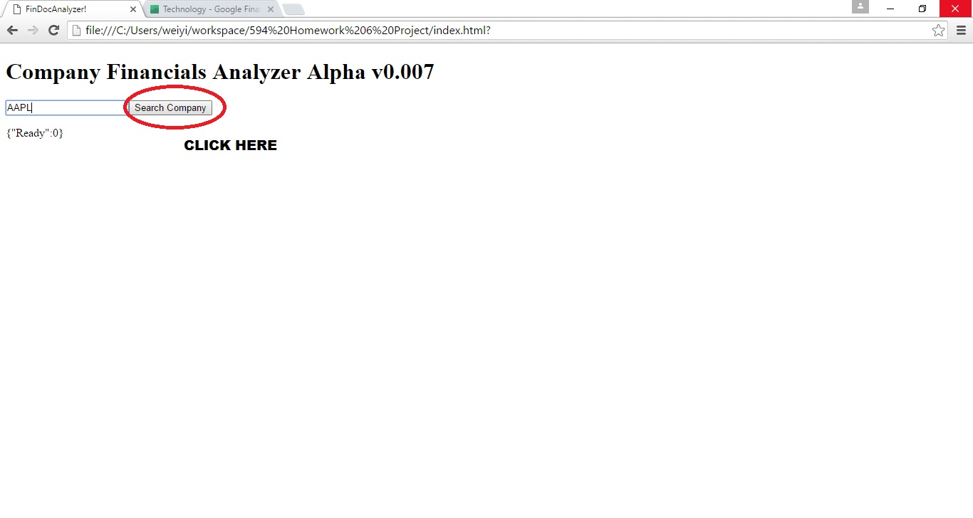

Step 3:

Wait for a few seconds and either some calculated valuation metrics should come up (or some error message due to the many, many limitations of the APIs)! That’s all there is to it! Feel free to search for a different company and see what happens—but not too frequently since you can only make 5 APIs a minute!

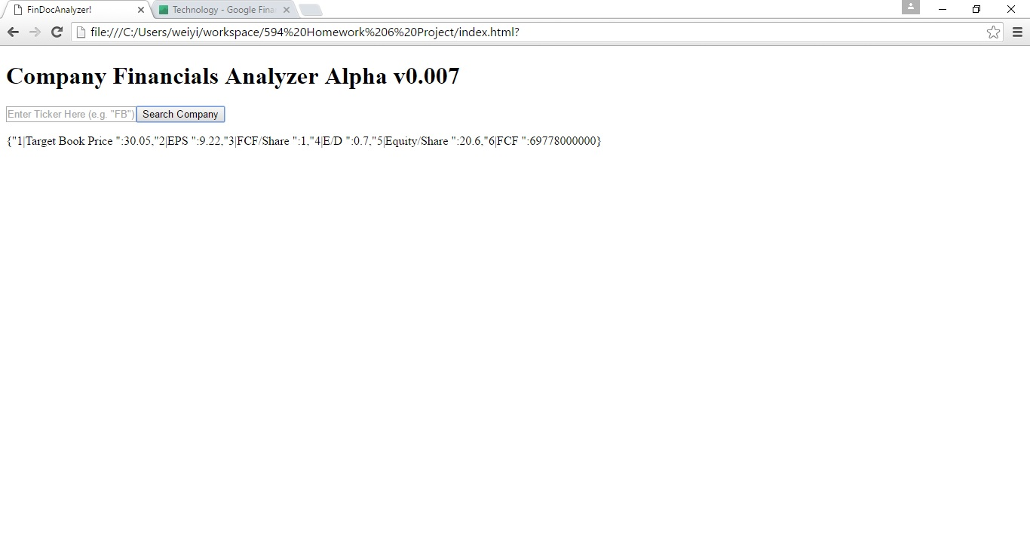

UHHHH… WHAT AM I LOOKING AT?

That’s a great question! These metrics are some of the most important indicators of a company’s health. Here are some explanations for each metric:

**Target Book Price:** the estimated Book Value (equity over shares) for the upcoming year. Since historical stock prices or industry multiples were somehow not available in any of the calls this is the best we can do. The target is calculated by comparing the most recent periods’ EPS with an average of its last five years’. This projected growth (or shrinkage) is compounded into the FCF over Shares multiple. This shows what, without market forces, the company should be valuated at based on its earnings and cash flow. Of course, in the actual market the stock prices won’t reflect this value at all, especially for tech companies with often unhealthy fundamentals!

CLASS/SEQUENCE DIAGRAMS

[Note: Class Diagram only available to java portion since my JS codes did not follow OOP design]

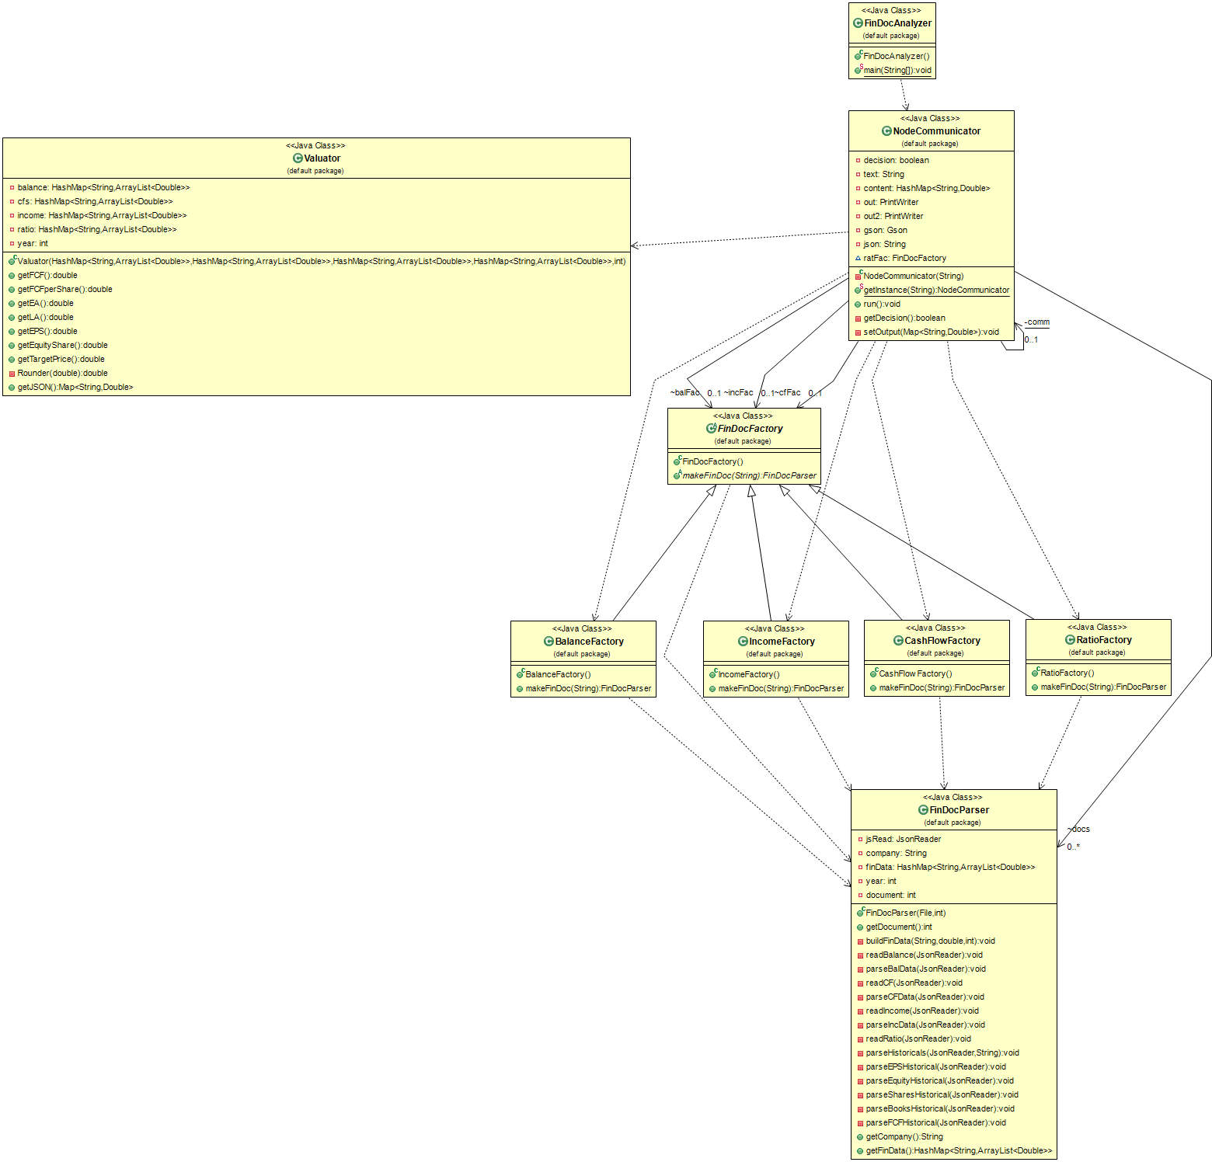

Making API calls:

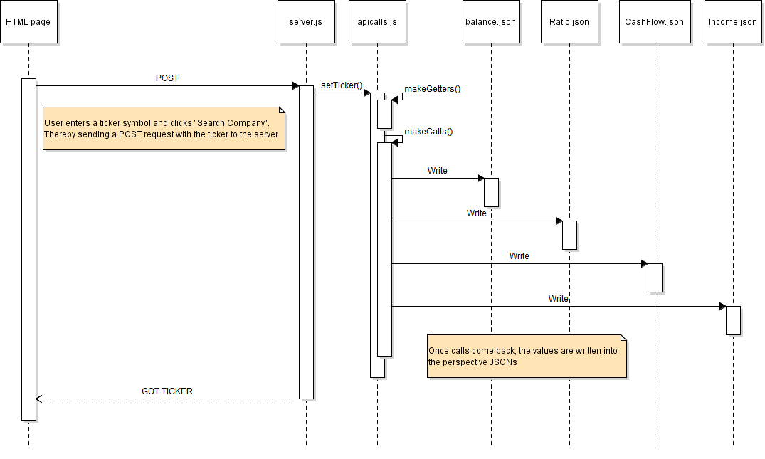

Getting Valuation Metrics (very wide image)

